
Student Registration and Tracking System
Final Project Report
ACE ENGINEERING COLLEGE - Hyderabad -Ghatksar
NAME : Bhukya Sunitha
Department: Information Technology
BATCH: 1 - TCS Last MileStone
Mentor: Ms. Mounika Katta

Phase 1: Problem Understanding & Industry Analysis.
- Many educational institutions manage student registration, course enrollments, and performance manually or using separate systems.
This leads to delays, errors, and extra workload for administrators and teachers.
- Tracking student attendance, academic progress, and wellbeing is difficult in real time.
- Parents are often unaware of their child’s progress or any issues.
Students under stress may go unnoticed, affecting their performance and wellbeing.
- A Salesforce app can register students, track courses, send alerts to parents, and notify them if a student is stressed.
Phase 2: Org Setup & Configuration
- Objective:
- Prepare the Salesforce environment (Org) and configure it for the Student Registration & Tracking App.
- Steps:
- Sign Up & Log In
- Go to Salesforce Developer Edition and create a free account.
- Switch to Lightning Experience.
- Create a New Lightning App
- Setup → App Manager → New Lightning App
- Name: Student Management App
- Add navigation items: Students, Courses, Enrollments, Reports
- Set Up Users & Profiles
- Create users: Admin, Teacher, Registrar
- Assign profiles and permissions (CRUD) for each object
- Customize Org Preferences
- Enable email deliverability (for parent alerts)
- Enable Enhanced Lightning Page Layouts
- Set default time zone and locale
- Prepare for Objects & Fields
- Make sure you have access to create custom objects and fields
- Enable necessary features like Flow Builder for automation
- 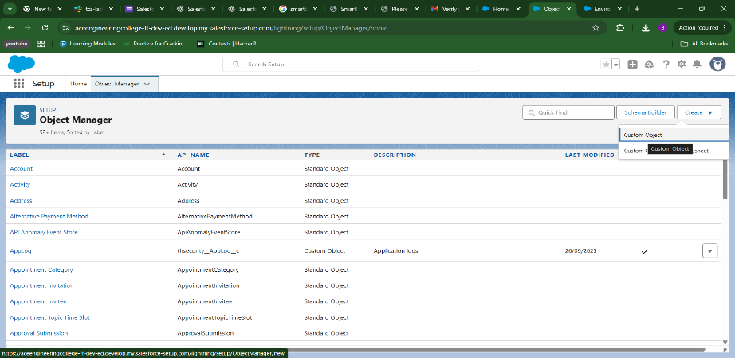

PHASE 2: Salesforce Setup (Admin Basics)
Step 1: Log in / Sign up for Salesforce Developer Edition
Step 2: Switch to Lightning Experience
Step 3: Create a Lightning App → Name: Student Registration and Tracking App →
- Save & Finish
  - Add navigation items later (like Students, Courses, etc.)
  - Save & Finish.

PHASE 3: Data Model (Admin Work)
Step 4: Create Custom Objects
Go to Setup → Object Manager → New Custom Object:
Object Name | Plural | Notes
Student | Students | Stores student info
Course | Courses | Stores course info
Enrollment | Enrollments | Junction between Student + Course

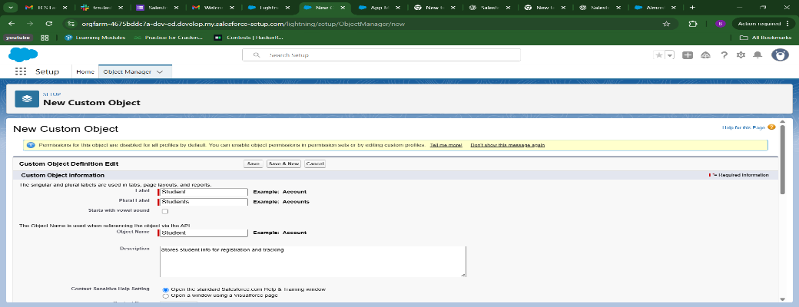
Create Fields
Student Object
- First Name (Text)
- Last Name (Text)
- Email (Email)
- Date of Birth (Date)
- Status (Picklist: Active, Inactive)
Course Object
- Course Name (Text)
- Course Code (Text)
- Description (Text Area)
- Credits (Number)

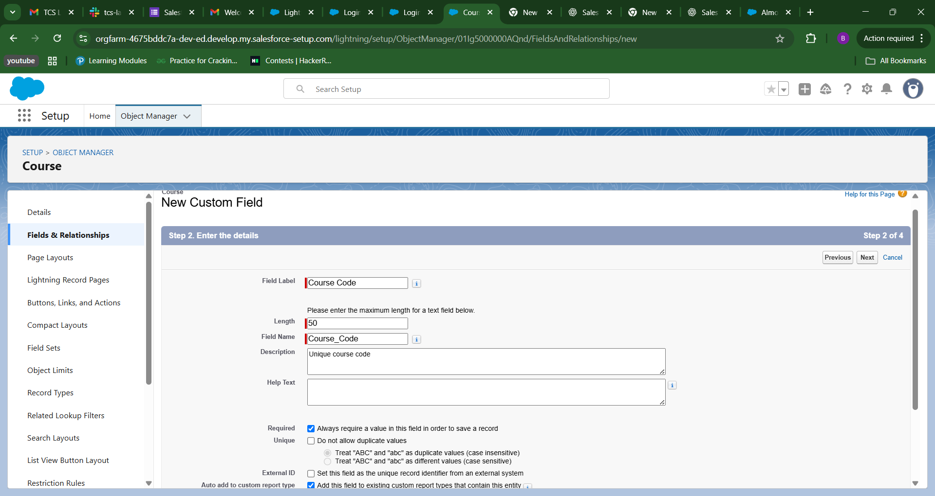
Enrollment Object
- Student (Lookup → Student)
- Course (Lookup → Course)
- Enrollment Date (Date)
- Grade (Picklist: A, B, C, D, F)
Step 6: Set Relationships
- Enrollment acts as a junction object between Student and Course.
→ This gives you a many-to-many relationship.
PHASE 4: Automation (Admin + Flow)
Step 7: Add a Record-Triggered Flow

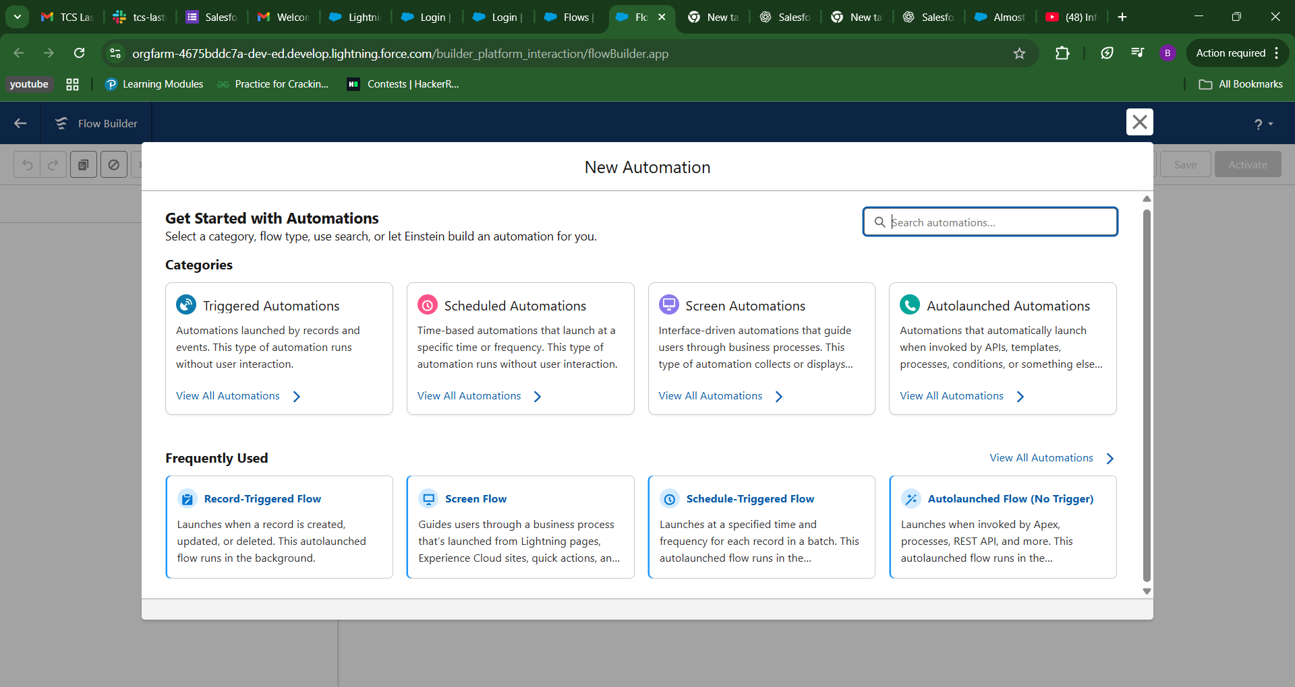

Example:
- Flow: When a new Student record is created → Send Welcome Email
  - Object: Student
  - Trigger: “When record is created”
  - Action: “Send Email Alert” (use an Email Template)

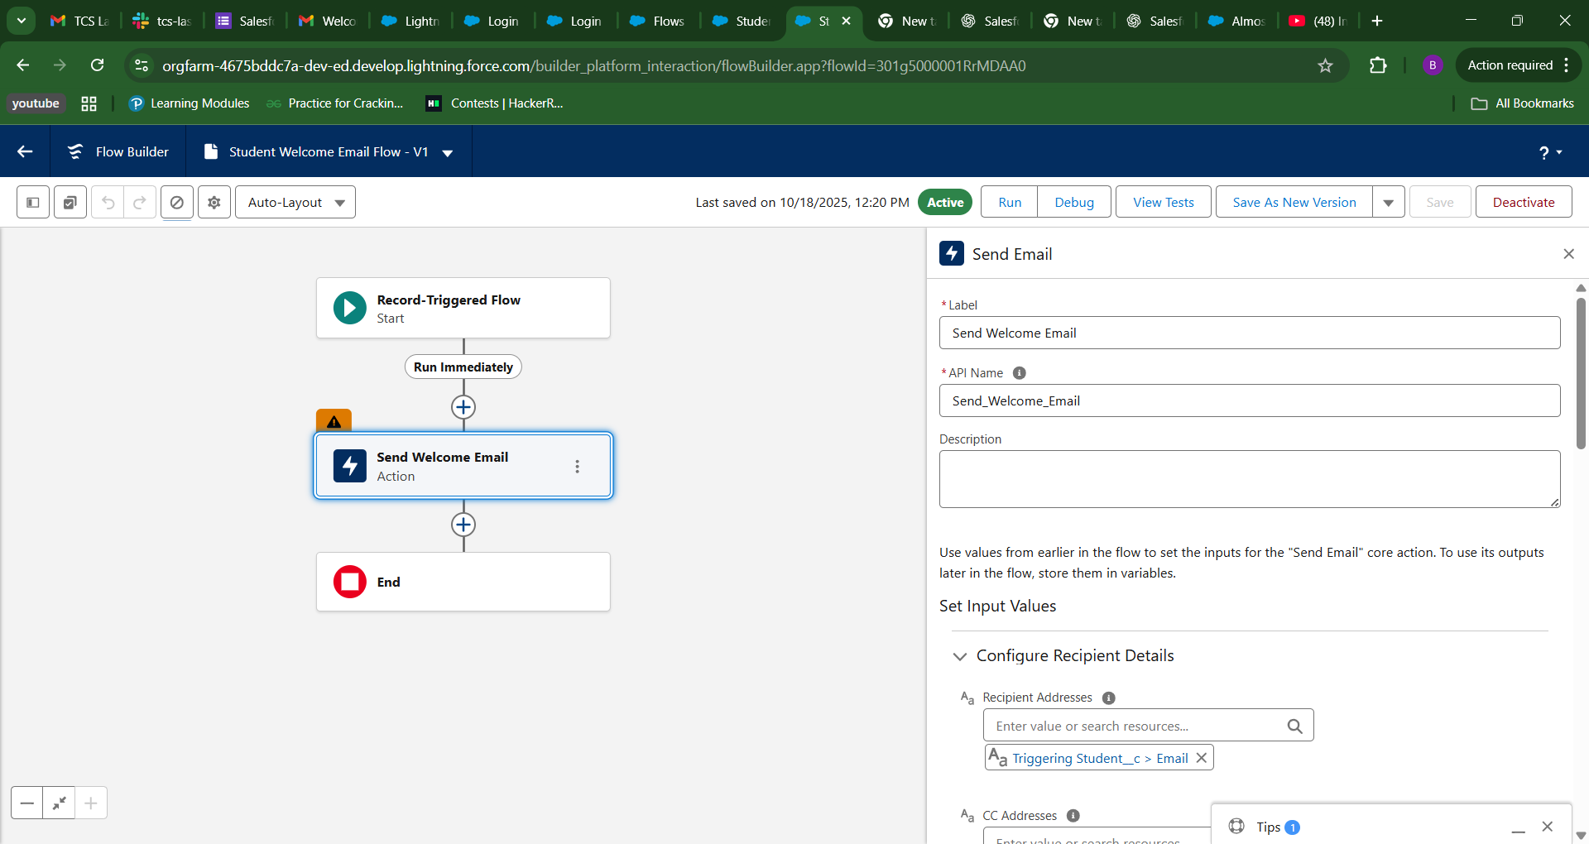

Step 8: Add Validation Rules
Examples:
- Email must contain “@”
- Date of Birth must be before today

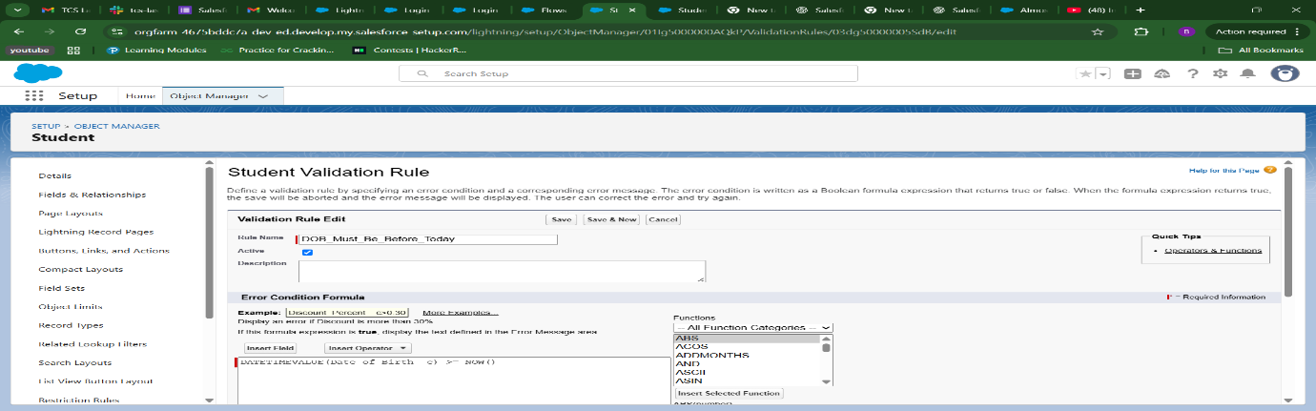

PHASE 5: Lightning App Builder (UI Work)
Step 9: Create Lightning Record Pages
- Setup → Lightning App Builder

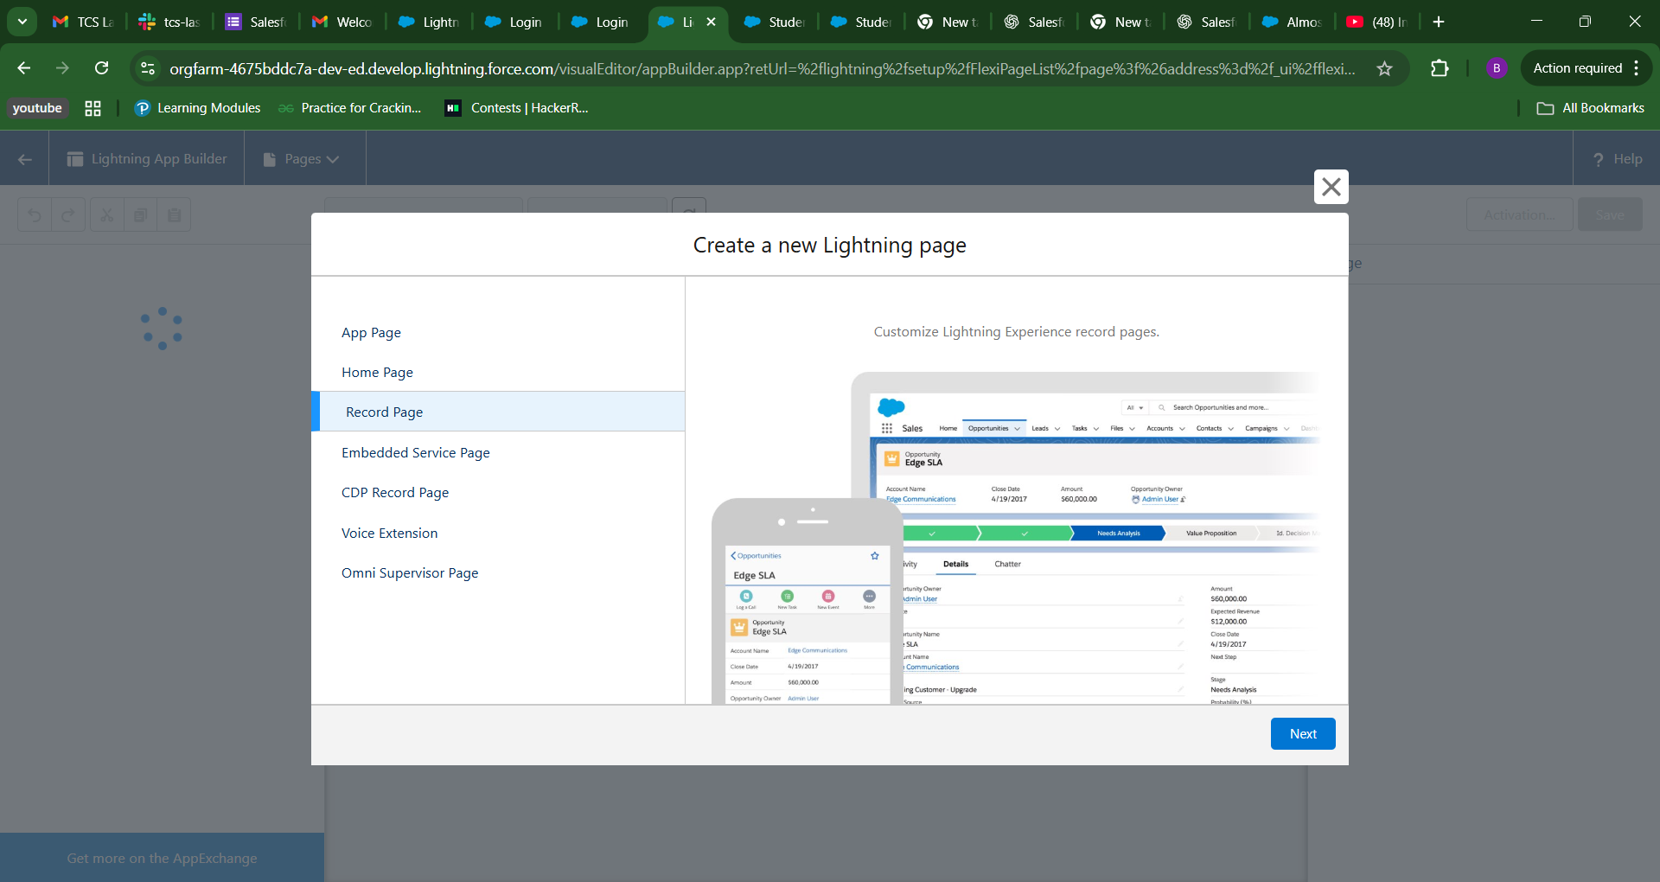

- Customize Student Record Page → Add Related List (Enrollments)
- Customize Course Record Page → Add Related List (Enrollments)
Now you can see which students are in each course and vice versa.

PHASE 6: Developer Add-ons (Optional Coding)
Step 10: Create a Custom Lightning Web Component (LWC)
If you want to display student data in a fancy dashboard:
- Use VS Code + Salesforce CLI
- Create an LWC:
- sfdx force:lightning:component:create --type lwc --componentname studentList --outputdir force-app/main/default/lwc
- Fetch Student data using Apex:
- public with sharing class StudentController {
- @AuraEnabled(cacheable=true)
- public static List<Student__c> getStudents() {
- return [SELECT Id, Name, Email__c, Status__c FROM Student__c];
- }
- }
- Display in the LWC using @wire.

PHASE 7: Reports & Dashboards
Step 11: Create Reports
- Create a Custom Report Type for Students and Enrollments
- Report: “Active Students per Course”
- Dashboard: Total Students, Active Enrollments, Average Grades

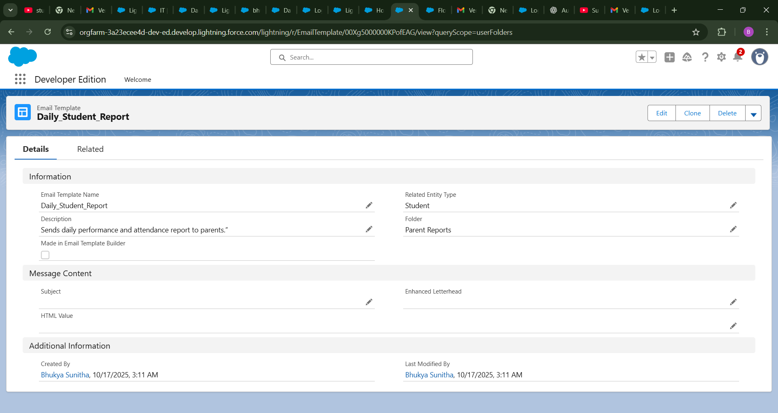

PHASE 8: Permissions & Profiles
Step 12: Control Access
- Create profiles like “Admin”, “Teacher”, “Registrar”
- Assign CRUD (Create/Read/Update/Delete) permissions on each object.

PHASE 9: Test & Deploy
Step 13: Testing
- Create sample students and courses
- Enroll students in courses
- Verify flows, validations, and reports.
PHASE 10: Optional Enhancements
- Add attendance tracking
- Add student portal (Experience Cloud)
- Add grading automation
- Integrate with Google Sheets or external APIs

